# **Screenshots of Gas Trick Project**

**Main Page**: User can enter the Zip code for US and get the current prices for Gasoline/Midgrade/Premium/Diesel.

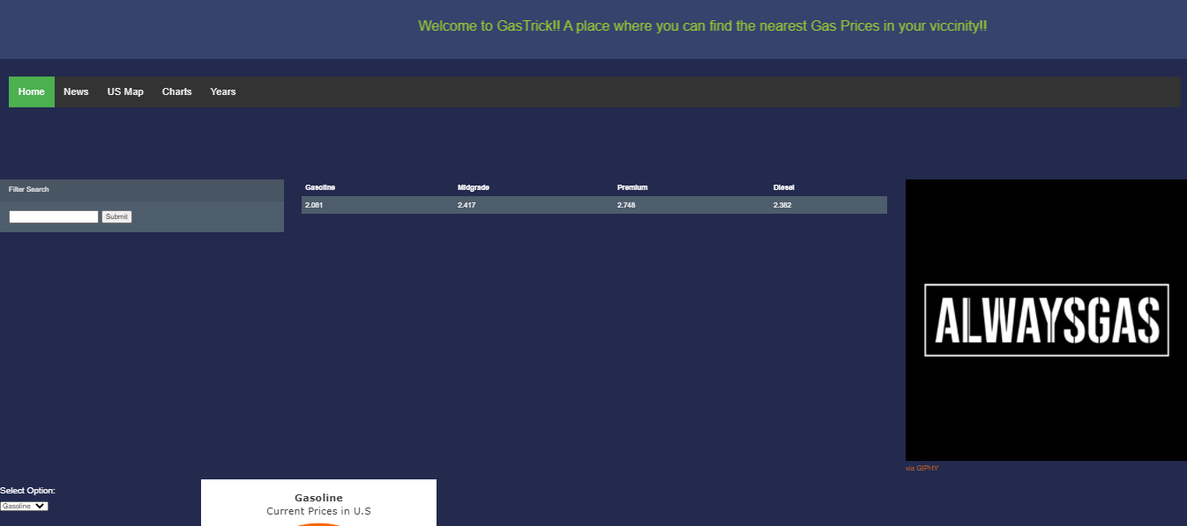

**Gauge Chart:** User can select the view of Gauge chart for Gasoline/Midgrade/Premium/Diesel Prices.

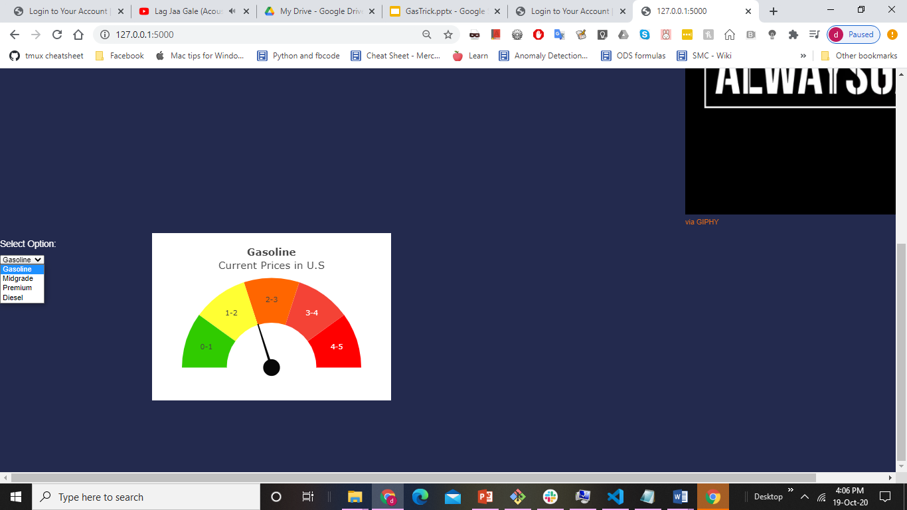

**US MAP:**It will display the current prices of different categories of gas in US states upon hovering.

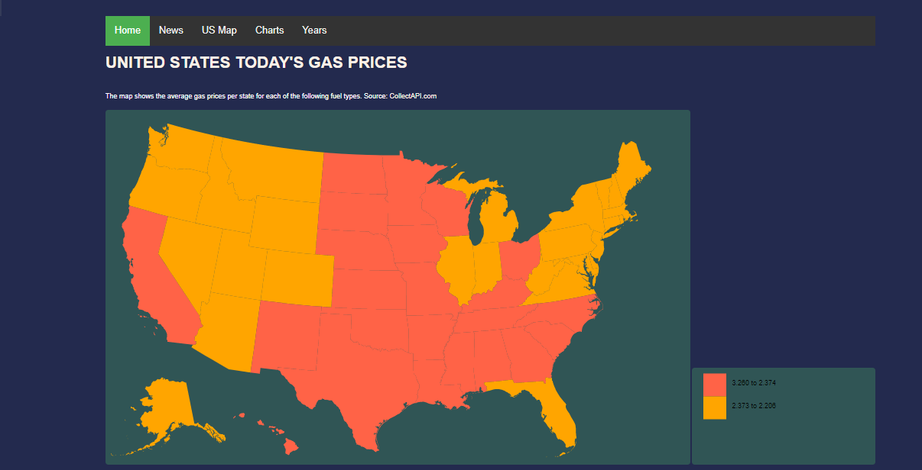

**Charts Page:**

**Chord Diagram:**It shows the US Imports/Exports of Crude oil in jul-2020 for different regions.

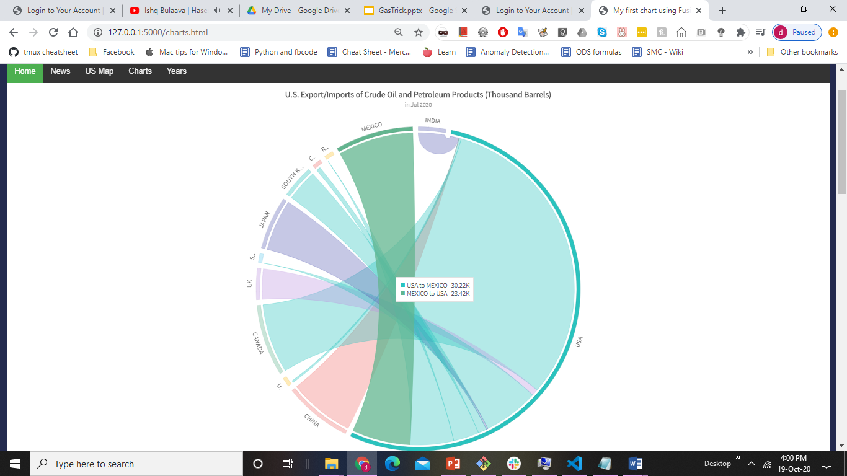

**Horizontal Bar Chart:**It shows the US Automobile Registrations by 2018

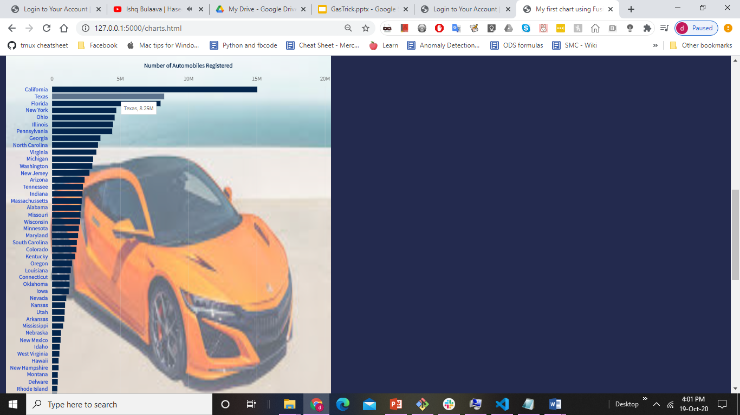

**Multi-Level Pie:** It shows the production of Crude Oil in different regions of US.

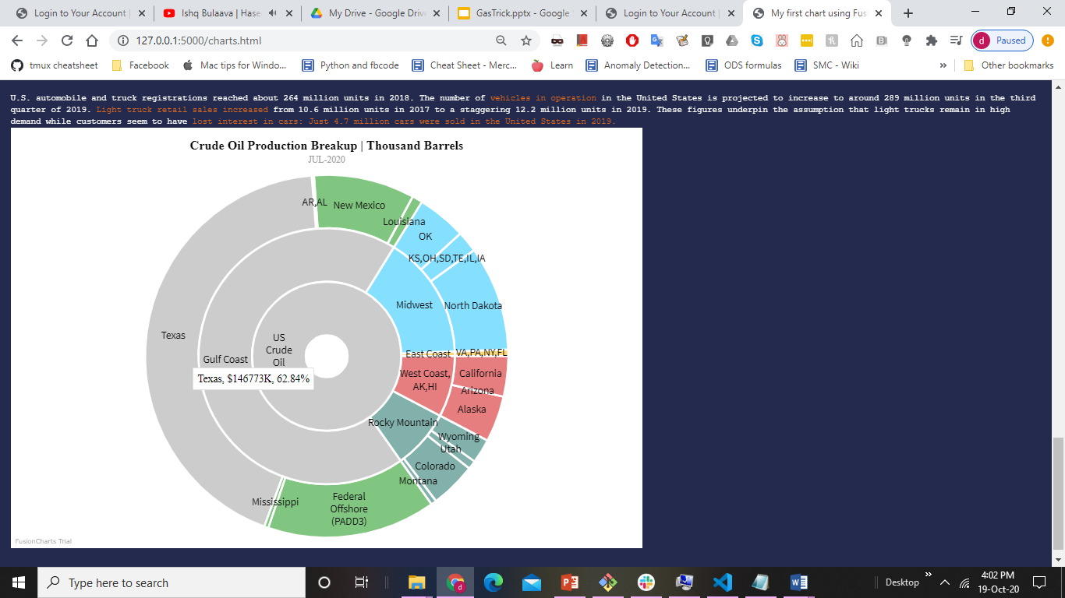

**News Page**:This is the page which scrapes current news about the Gasoline/Diesel Prices and how they are made from different pages using selenium.

